Effectiveness Analysis of Core Modules
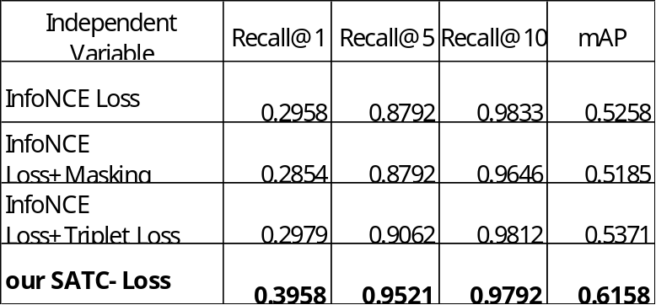
Core Hyperparameter Analysis
- The impact of the weight parameter $α$
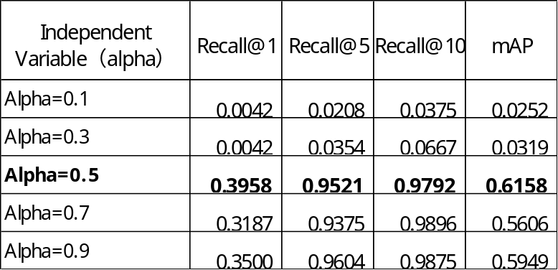

- The impact of the similarity threshold $τ_{sim}$
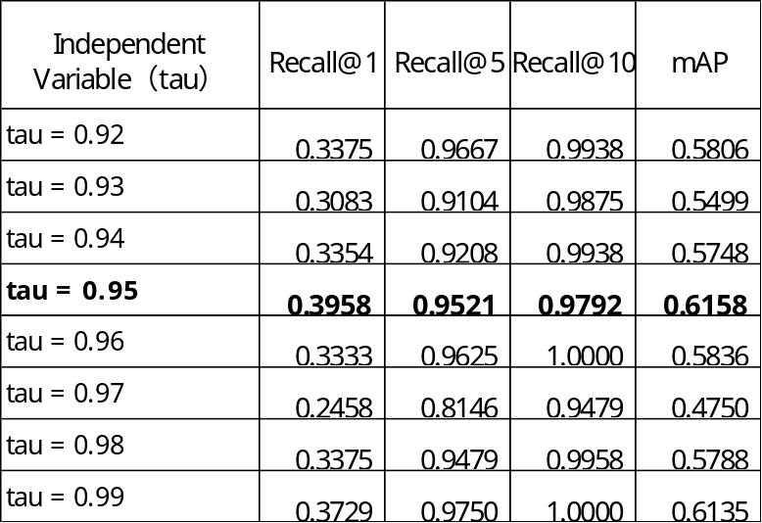

- The impact of the triplet margin
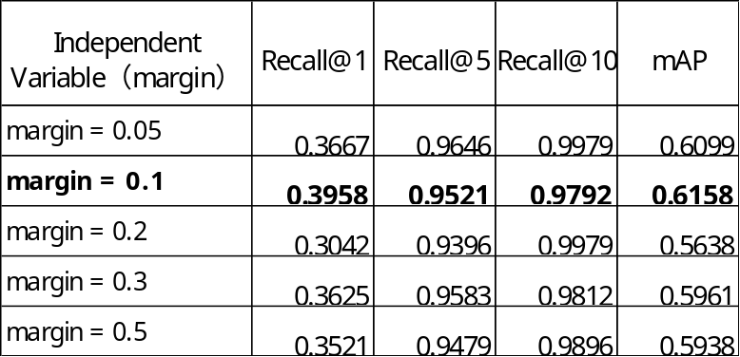

Effect of Batch Size
